PROFORMA FOR THE APPROVAL PROJECT PROPOSAL

PRN No: Roll No: 14

- Name of the student: Samiksha Sanjay Halve
- Title of the project: Multi Modal Smart Vehicle

- Name of the Guide: Mrs. Palak Agrawat

- Teaching experience of guide: 5 Years
- Is this your first submission? : Yes

Signature of Student Signature of Guide

Date: Date:

Signature of the Coordinator Date:

MULTI MODAL SMART VEHICLE

A Project Report
Submitted in partial fulfillment of the Requirements for the award of the Degree of

BACHELOR OF SCIENCE (INFORMATION TECHNOLOGY)

By
Samiksha Sanjay Halve Roll No: - 14

Under the esteemed guidance of
Mrs. Palak Agrawat
(HOD of IT Department)



DEPARTMENT OF INFORMATION TECHNOLOGY
ST. ROCK’S COLLEGE OF ARTS, COMMERCE AND SCIENCE
(Affiliated to University of Mumbai) MUMBAI- 400092 MAHARASHTRA
2025-2026

ST. ROCK’S COLLEGE OF ARTS, COMMERCE AND SCIENCE
(Affiliated to University of Mumbai)
MUMBAI-MAHARASHTRA-400092

DEPARTMENT OF INFORMATION TECHNOLOGY

CERTIFICATE

This is to certify that the project entitled, "Multi Modal Smart Vehicle", is bonafied work of SAMIKSHA SANJAY HALVE bearing Roll No: 14 submitted in partial fulfillment of the requirements for the award of degree of BACHELOR OF SCIENCE in INFORMATION TECHNOLOGY from University of Mumbai.

Internal Guide Coordinator

External Examiner

Date: College Seal

ABSTRACT
This project outlines the creation of a smart, multi-functional robotic vehicle powered by an Arduino microcontroller. The car is designed with three distinct modes for safe and flexible operation. First, it uses an ultrasonic sensor for obstacle avoidance, allowing the car to move safely and autonomously without crashing into objects. Second, users can control the car manually using a Bluetooth connection linked to a simple smartphone application. Third, the system incorporates voice commands, enabling hands-free control by speaking simple instructions into the mobile app. This vehicle successfully integrates modern wireless communication and sensing technology into a single platform. The result is a highly interactive, adaptable, and reliable robotic tool suitable for both educational demonstrations and practical home assistance applications. Testing confirmed the system’s effectiveness in detecting obstacles and its quick response to all remote commands.

TABLE OF CONTENTS
- Introduction 6
  - Background 6
  - Aim and Objectives 6
  - Purpose, scope and Applicability 8
    - Purpose 8
    - Scope 8
    - Applicability 9
- Survey of Technologies 10
  - Existing System 10
  - Proposed System (Multi Modal Smart Vehicle) 11
- Requirements and Analysis 12
  - Problem Definition 12
  - Requirement Specification 13
    - Functional Requirement 13
    - Non-Functional Requirement 14
  - Planning and Scheduling 14
    - Gant Chart 15
    - Pert Chart 15
  - Software and Hardware Requirement 16
    - Software Requirements 16
    - Hardware Requirements 16
  - Conceptual Model 17
    - Block Diagram 17
    - Class Diagram 17
    - Flow Chart 17
    - Circuit Diagram 18
- System Design 19
  - Basic Modules
  - Procedural Design
  - Algorithm Design

Chapter 1

Introduction

Background

The field of robotics is quickly moving toward intelligent systems that can understand their environment and react dynamically. Today, the demand is high for user-friendly robots that are not limited by old technology. Traditional remote-controlled vehicles often relied only on simple radio frequencies, forcing the user to stay in sight of the robot. This limited where and how the vehicle could be used. We need new robotic platforms that are versatile and can be controlled using modern, smart methods.

This project directly addresses those limitations by integrating three advanced features into one platform. We are using modern wireless solutions like Bluetooth and voice recognition, which remove the need for line-of-sight control and allow for flexible operation. Crucially, we are also adding sensor-based avoidance (which you refer to as Optical Detection). This capability allows the vehicle to become partially autonomous—it can safely sense objects and navigate around them, protecting both itself and its surroundings.

The core idea is to create a single, cohesive system that can switch between autonomous safety functions and flexible human control interfaces. This Multi-Modal Smart Vehicle built efficiently using the Arduino platform—is designed to be both functional and easy to operate. By combining autonomy, Bluetooth control, and voice commands, the project serves as a perfect educational tool and a strong prototype for future, highly interactive applications in areas like home assistance and general automation.

Aim and Objectives

The primary aim of this project is to design and implement a highly intuitive, multi-mode intelligent robotic vehicle built on the Arduino platform. This vehicle will be capable of seamlessly integrating autonomous obstacle avoidance using ultrasonic sensors with dual remote-control functionalities via a smartphone: Bluetooth-based manual navigation and voice command recognition. The ultimate goal is to deliver a versatile and reliable robotic platform that offers enhanced flexibility, usability, and safety in diverse operating environments.

Objectives
The following objectives outline the steps necessary to achieve the project's aim:
- Core System Integration : - To select and interface the Arduino microcontroller with all essential hardware components, including the motor driver, DC motors, ultrasonic sensor, and Bluetooth module. To establish reliable wireless communication between a smartphone application and the vehicle using the Bluetooth module, ensuring efficient data exchange for all control modes.

- Development of Autonomous Capabilities : - To design and implement an Autonomous Obstacle Avoidance System where the robot utilizes an ultrasonic sensor to detect objects accurately in real-time. To develop microcontroller algorithms that enable immediate and precise response to detected obstacles, ensuring safe, smooth, and collision-free navigation in dynamic environments.

- Implementation of Multi-Modal Control : - To incorporate a voice recognition system via the smartphone application, allowing users to issue specific movement commands (e.g., "forward," "stop") and ensuring seamless interpretation by the Arduino. To establish a functional Bluetooth Remote Control interface that allows manual navigation via virtual buttons on the smartphone app. To develop a program that creates a cohesive control hierarchy, allowing the user to switch effectively between Voice, Bluetooth, and Autonomous modes, while also ensuring the obstacle avoidance feature overrides manual commands when safety is critical.

- System Performance and Validation : - To design the motor and chassis system for precise movement and turning accuracy to optimize the vehicle's manoeuvrability. To test and validate the robot’s responsiveness, range, and accuracy in all three control modes (Avoidance, Voice, and Bluetooth) across various real-world environmental conditions. To optimize power management through efficient component selection and code design to extend the robot's operational time and enhance overall system reliability.

Purpose, scope and Applicability

Purpose

The main purpose of this project extends beyond merely assembling a kit; it is to design, implement, and validate a highly functional prototype of a multi-mode intelligent robotic vehicle. This prototype specifically aims to achieve and demonstrate two critical outcomes in contemporary robotics:

      - Demonstrating Seamless Multi-Modal Control: The three ways to control the robot are: automatic safety, where it uses sensors to instantly stop and avoid crashes; direct control, where a person steers it precisely using a phone app; and voice control, which allows for easy, hands-free operation using simple spoken commands.
      - Advancing Human-Machine Interaction (HMI) and Usability: This project has two key purposes: it functions as an effective teaching tool for students to easily learn about how integrated control systems and sensors work together. More importantly, it acts as a proof-of-concept for developing future smart robots for home assistance and automation, proving that complex tasks require a high degree of safety, flexibility, and intuitive user commands.
      - Promote Engagement: Foster a more interactive and engaged learning environment through the use of discussion forums, where students can participate in academic discussions, collaborate with peers, and seek assistance from faculty.
      - Enhance Accessibility: Offer a web-based solution that can be accessed from anywhere, allowing students and faculty to stay connected and manage academic tasks regardless of their location.

Scope

The scope of this project is meticulously defined to ensure all objectives are achievable within the constraints of time, resources, and the Arduino platform's capabilities. The project's implementation and resulting functionalities will be strictly limited to the following five domains:

Platform and Mechanical Constraints: - The entire system is built exclusively on the Arduino microcontroller, which imposes strict limits on processing power and memory. Implementation is confined to a standard Four-Wheel Drive (4WD) mobile chassis. The robot is designed only for operation on flat, indoor surfaces and does not include all-terrain capabilities or advanced suspension.
- Autonomous and Connectivity Constraints: - Autonomous operation is strictly limited to basic, real-time obstacle avoidance using only a single front-mounted ultrasonic sensor. The avoidance logic is confined to simple, reactive algorithms (e.g., Stop-Scan-Turn) and excludes complex features like pathfinding (SLAM) or environmental memory. All remote control is restricted to Standard Class 2 Bluetooth, limiting the effective operational range to approximately 10 meters.

Human-Machine Interface (HMI) Constraints: - The primary user interface for sending commands is handled entirely by an external Android application. The voice recognition function is performed exclusively by the smartphone's operating system, which then sends simplified commands to the Arduino via Bluetooth. The project does not include on-board voice processing or the development of complex graphics within the Arduino's limited programming scope.

Applicability

The Multi-Modal Smart Vehicle is highly applicable across numerous fields due to its versatile combination of autonomous safety and flexible remote control. This technology is crucial for smart home automation and hands-free control systems, allowing devices to interact safely within human environments. Furthermore, it serves as an excellent educational tool for students to gain hands-on experience with embedded systems, sensor integration, and wireless communication. Professionally, the concept is scalable for industrial use, inspiring systems like Automated Guided Vehicles (AGVs) in warehouses, or adaptable for domestic tasks such as simple cleaning and security robots. Its unique ability to seamlessly switch between collision-free navigation and user-driven command makes it ideal wherever safe, efficient, and intuitive operation is paramount.

Chapter 2

Survey of Technologies

Existing System

Currently, various robotic systems are available, but they often suffer from significant limitations that restrict their versatility and accessibility. Existing basic robotic cars typically fall into two single-purpose categories: simple RF-controlled cars lacking autonomous features, or dedicated autonomous robots (like line-followers) lacking flexible human control.

- Limited Multi-Modality and Control Flexibility: Most existing systems are single-purpose, offering either full autonomy or simple manual control, but rarely both in a unified, user-friendly package. This forces users to choose a single interaction method (like only an app or only a joystick), which restricts accessibility and fails to accommodate users who may prefer alternative interaction methods, such as voice command.

- Lack of Dynamic Autonomy: Many established robots rely heavily on pre-programmed paths or constant manual control rather than real-time environmental awareness. This limits their ability to adapt to unexpected situations. They lack the sophisticated logic needed for real-time obstacle detection and efficient, autonomous avoidance in dynamically changing environments, thereby limiting their practical utility.

- High Barrier to Entry (Cost and Complexity): Advanced robotic systems that do offer high functionality tend to be expensive and utilize specialized hardware, making them inaccessible for students, hobbyists, and small-scale applications. Conversely, cheaper commercial models often limit customization and expandability, making it difficult for users to modify or enhance the robots for different applications or educational purposes.

Proposed System (Multi Modal Smart Vehicle)

This project aims to overcome these limitations by integrating multiple control options, affordability, and user-friendly features. Key advantages of this project include:

- Seamless Multi-Mode Integration and Enhanced Autonomy: The system seamlessly integrates three distinct modes of operation: Autonomous Obstacle Avoidance (using sensors for real-time navigation), Bluetooth Remote Control, and Voice Control (using speech-to-command via a smartphone app). This unique combination provides flexible operation options while ensuring enhanced safety and efficiency in dynamic environments.

- Superior Accessibility and User-Friendly Design: Unlike rigid, complex existing systems, the proposed robot leverages a user-friendly design by utilizing an intuitive mobile application for all remote controls. The inclusion of voice command recognition ensures that users of all technical backgrounds can operate the robot easily and hands-free, making the system accessible to a broader audience.

- Cost-Effective, Customizable, and Open Source: The entire project is built on the Arduino open-source platform, making it highly affordable and DIY-friendly for students, educators, and hobbyists. The modular design ensures the system is inherently customizable and expandable, allowing users to easily modify or enhance the robot's functionality, bridging the gap between low cost and high functionality in modern robotics.

Chapter 3

Requirements and Analysis

3.1 Problem Definition

The growing need for intuitive, multifunctional robots in daily life presents a core research problem: how to reliably combine autonomous obstacle avoidance, mobile voice control, and Bluetooth operation within a single, resource-constrained platform like the Arduino. The main difficulty lies not in implementing these features individually, but in achieving their seamless, non-conflicting integration and synchronization. Addressing this challenge is crucial for developing the genuinely versatile robotic systems required for diverse real-world applications.

Key Research Challenges Addressed

Reliable Multi-Modal Synchronization and Control Hierarchy: - The most significant challenge is establishing a cohesive system that effectively manages and mediates potential conflicts between three distinct control inputs: autonomous sensor-based avoidance, direct Bluetooth manual commands, and mobile voice instructions. This requires developing a non-conflicting control hierarchy that maintains instantaneous responsiveness and prevents latency or operational errors. The system must gracefully handle scenarios where, for example, a voice command attempts to override an active autonomous avoidance maneuver.

Real-time Obstacle Perception and Adaptive Navigation :- Developing robust algorithms for fast and reliable detection of obstacles in varied environments remains a critical necessity. The challenge lies in ensuring that the robot's simple ultrasonic sensors can quickly translate raw distance data into accurate, reliable decisions. This is essential to facilitate smooth, collision-free navigation while maintaining operational speed and adapting effectively to dynamic, non-uniform conditions often found in home or educational settings.

Voice Recognition Accuracy and Enhanced User Experience (UX) :- Implementing a voice control system that is genuinely practical requires overcoming the inherent challenges of real-world recognition. This involves maximizing command accuracy across diverse user accents and environmental noise through the mobile application interface. Furthermore, researching user interaction patterns is vital to ensure that both the voice and Bluetooth controls are intuitive and accessible to users of different ages and technical backgrounds, thereby maximizing the system's overall utility.

Performance Validation in Real-world Scenarios :- The final challenge is empirically testing and validating the robot's fully integrated performance under diverse, uncontrolled, real-world conditions. Gathering measurable data on its responsiveness to both voice and Bluetooth commands, the effectiveness of its multi-modal switching mechanisms, and the reliability of its autonomous navigation is essential. This data will reveal the robot's practical limitations and inform the future enhancements necessary to prove its potential application for a variety of real-world tasks.

Requirement Specification

3.2.1 Functional Requirements

Obstacle Detection and Avoidance :- The robot must use ultrasonic sensors to detect obstacles within a specified range. It should autonomously change direction to avoid collisions.
- Bluetooth Connectivity for Remote Operation :- The robot should connect to a mobile application via Bluetooth. Users must be able to control the robot's movement manually through the app.
- Real-Time Movement Execution :- The robot must respond to voice or Bluetooth commands with minimal delay. It should continuously check for obstacles while moving autonomously.
- Power Management :- The system should notify the user when the battery is low. It must efficiently manage power consumption to extend battery life.
- User-Friendly Interface :- The mobile application should provide clear options for both voice and manual control. The app should display real-time connection status and command execution feedback.

- Emergency Stop Feature :- The robot should have a manual stop command to halt movement immediately if needed. A physical button on the robot may also be included for emergency stopping.
- Voice Control via Mobile Application :- The robot should process voice commands received from the mobile app. It must execute commands such as move forward, backward, turn left, turn right, and stop based on user input.

3.2.2 Non-Functional Requirements

- Performance: - The robot must process obstacle detection and command execution in real time (response time< 1 second). Bluetooth connectivity should maintain a stable range of at least 10 meters.
- Reliability :- The robot should operate continuously for at least 30 minutes on a full battery charge. It must handle minor obstacles (e.g., small bumps) without failure.
- Usability: The system should be designed for easy setup and operation, requiring minimal technical knowledge. The mobile app should have a simple and intuitive interface with clear instructions.
- Security: Only authorized devices should be able to connect to the robot via Bluetooth. The system should reject unrecognized or conflicting voice commands.
- Cost Efficiency: The total cost of building the robot should remain affordable while maintaining good performance. Open-source software and easily available components should be used to reduce expenses.
- Maintainability and Scalability: The robot's software should allow for future updates and additional functionalities (e.g., adding more sensors or control methods). Hardware components should be easily replaceable and modifiable for further improvements.
By fulfilling these functional and non-functional requirements, this project ensures that the robot is reliable, efficient, and easy to use while maintaining flexibility for future enhancements.

Planning and Scheduling

A well-structured planning and scheduling approach is essential for the successful implementation of the Arduino-based robotic project. This section outlines the phases, tasks, and timelines involved in the project development.

Gantt Chart
A Gantt chart provides a visual timeline for the tasks in the project, showing the planning and scheduling of entire project.

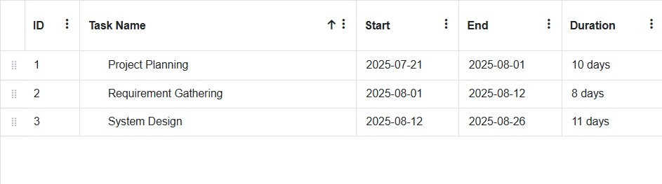
Figure 1: Gantt Chart 1

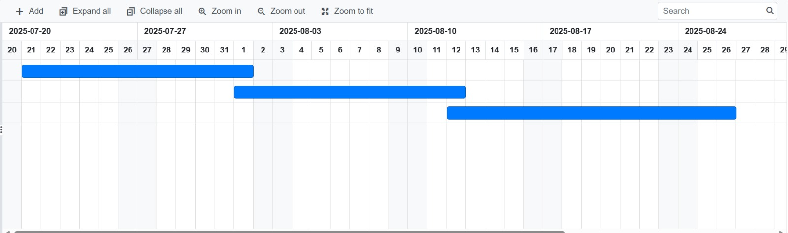
Figure 2: Gantt Chart 2

Pert Chart

A PERT (Program Evaluation and Review Technique) Chart helps visualize the project workflow, dependencies, and estimated completion times. Below is a breakdown of the project in terms of tasks and dependencies.
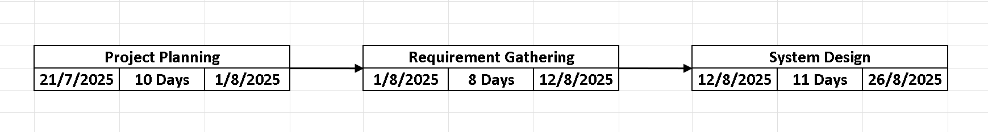

Software and Hardware Requirements

Software Requirements

Programming Environment: - Arduino IDE (for writing and uploading code to the Arduino board)
- Embedded Programming Language :- C++ (Arduino Sketch) (for coding microcontroller functionalities)
- Mobile Application Development :- MIT App Inventor / Android Studio (for developing the mobile app for voice and Bluetooth control)
- Communication Protocols :- Communication (UART) for Bluetooth Module. HC-SR04 Library (for ultrasonic sensor integration). Servo Library (for controlling the SG90 servo motor)
- Operating System Compatibility :- Windows, macOS, or Linux (for coding and compiling Arduino programs). Android-based smartphone (for running the mobile application)
- Version Control (Optional) :- GitHub / Git (for managing code and version tracking)

Hardware Requirements

- Microcontroller :- Arduino UNO R3 (to control the robot's functions)
- Motor Driver : - L293D Motor Driver (to control the movement of 4 DC motors)
- Motors and Chassis :- 4 x DC Motors (for movement). 1 x 4WD Chassis RC Car (to house the components and provide stability).
- Obstacle Detection Sensor :- 1 x HC-SR04 Ultrasonic Sensor (for detecting obstacles). 1 x HC-SR04 Holder (to mount the sensor)
- Wireless Communication : - 1 x Bluetooth Module (for remote control via mobile app)
- Servo Motor : - 1 x SG90 Servo Motor (to rotate the ultrasonic sensor for better obstacle detection)
- Power Supply :- 2 x 9V Batteries (to power the motors and Arduino). 2 x 9V Battery Connectors (for battery connection). 2 x Power Switches (for turning the system on/off)
- Servo Motor : - Jumper Wires (for electrical connections between components)

Conceptual Model

Block Diagram

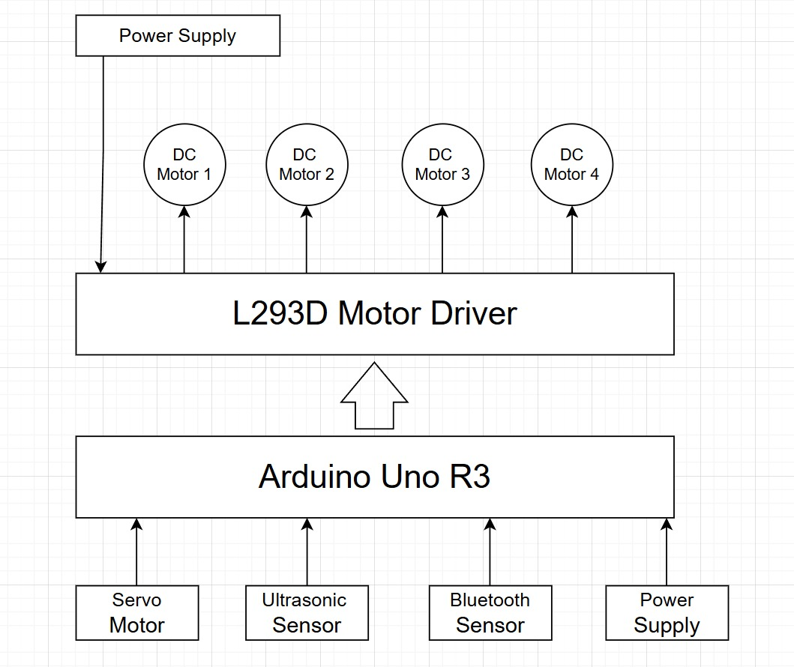

Class Diagram
Figure 4: Block Diagram

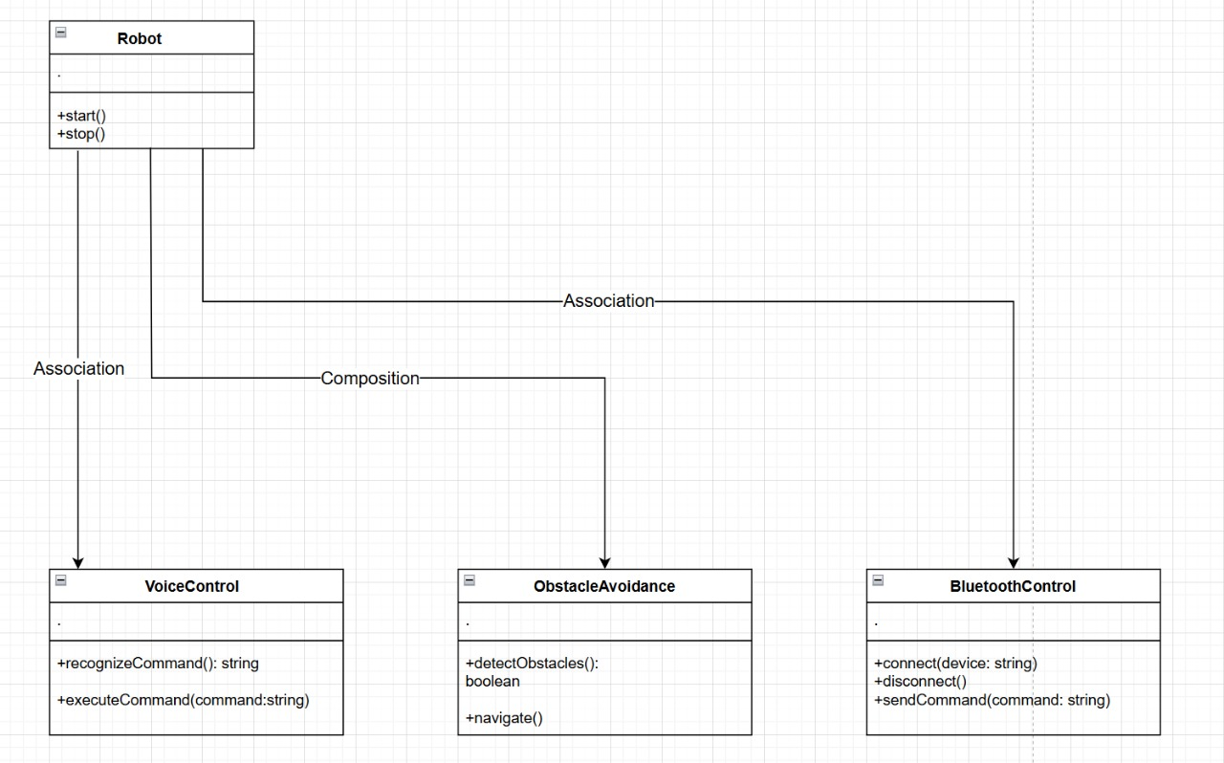

Figure 5: Class Diagram

Flow Chart

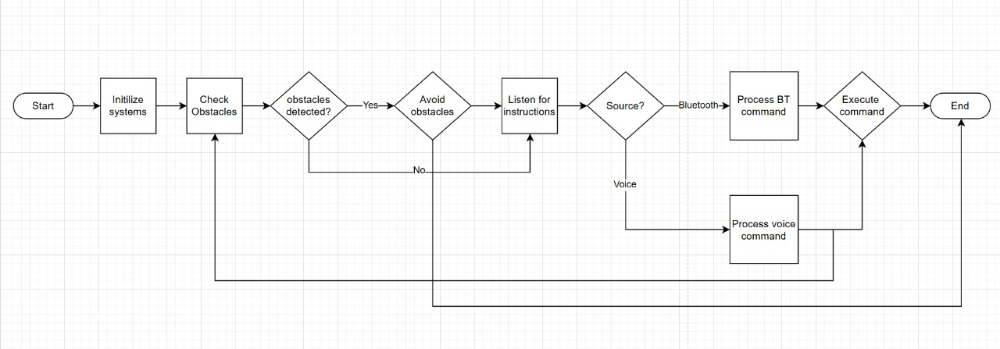

Figure 6: Flow Chart

Circuit Diagram

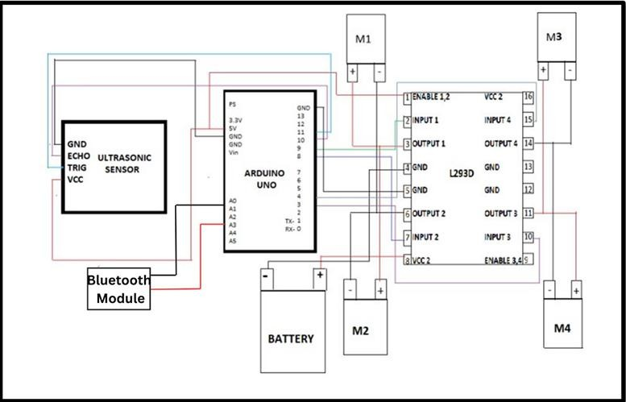
Chapter 4

System Design

4.1 Basic Modules

The system's design is modular, meaning it is broken down into independent, distinct units based on their function. The robot operates based on four primary modules:

Sensing Module (Input): Primarily uses the HC-SR04 Ultrasonic Sensor to measure the distance to objects in the robot's path.

Control and Processing Module (Core): Centered around the Arduino UNO Microcontroller. It executes the core control logic, determines the active operating mode, and sends appropriate signals to the driving module.

Communication Module (Input): Manages wireless user interaction using the HC-05/06 Bluetooth Module to establish a serial data link with the external Android application.

Driving Module (Output): This module is responsible for executing the physical movement commands. It consists of the DC Motors and the L293D Motor Driver , which regulates the direction and speed (via PWM) of the four wheels based on signals received from the Control Module.

4.2 Procedural Design

The procedural design outlines the structured sequence of operations the system follows from start-up to execution, ensuring reliable, non-conflicting performance.

System Startup and Initialization:

Hardware Check: Upon power-up, the Arduino initializes all necessary I/O pins, timer registers, and serial communication ports (for Bluetooth).

Module Initialization: The Bluetooth module attempts to connect with the paired mobile application. The ultrasonic sensor is primed for distance measurement.

Default Mode: The system enters a default standby mode (e.g., Autonomous Mode), waiting for an external command or a detected obstacle.

Operational Loop (Main Loop):

The system executes a continuous loop, prioritizing inputs based on a set hierarchy:

Collision Check: The loop first checks the Ultrasonic Sensor data. If an obstacle is detected below the critical threshold (e.g., 20 cm), the system immediately halts the current action and initiates the Avoidance Procedure, overriding any active remote command.

Command Check: If no imminent obstacle is detected, the loop checks the Bluetooth Communication Module for incoming commands (Voice or Manual).

Mode Execution: Based on the received input or the default state, the system executes the appropriate movement logic within the active mode (e.g., drive forward, turn left).

4.3 Algorithm Design

The core functionality of the robot is defined by two primary algorithms that manage the vehicle's movement and mode switching.

Obstacle Avoidance Algorithm (The Safety Procedure)

This algorithm executes a reactive, sensor-based decision-making process:

Measure Distance: Continuously use the ultrasonic sensor to measure D, the distance to the nearest object.

Check Threshold: Compare D to the predefined critical threshold (T, e.g., D<20 cm).

React:

IF D<T: STOP all motors immediately.

Scan: (If a servo is used, scan) or use pre-programmed timing to quickly check distance to the left and right.

Decide: Turn the robot in the direction that offers the greatest clear space.

Continue: Resume movement in the new direction.

IF D≥T: Resume the currently active operational mode (Voice or Bluetooth).

Multi-Mode State Machine Algorithm (The Control Hierarchy)

This algorithm manages the switching between the three control modes based on user input, while always maintaining the priority of safety:

Default State: Start in Autonomous Mode (moving forward while checking for obstacles).

Mode Switch Input: A new command from the Bluetooth/Voice input is received.

Prioritize Safety: IF the Obstacle Avoidance Algorithm is active, IGNORE the new remote command.

Change State: ELSE (No imminent threat):

The system recognizes whether the input is a Voice Command or a Manual Bluetooth Command. The state is updated to the corresponding mode (Voice Control or Bluetooth Control). Execute the command until a new mode command is received or the user sends a "STOP" command to revert to a Standby State (or re-enter Autonomous Mode).

